EXPT NO: 1 | BUILDING AND TRAINING A SIMPLE ARTIFICIAL NEURAL NETWORK (ANN) FOR REGRESSION AND CLASSIFICATION
DATE: 24.07.2026

PRE-LAB QUESTIONS (PROVIDE BRIEF ANSWERS TO THE FOLLOWING QUESTIONS)

1. What is an Artificial Neural Network (ANN)?
An Artificial Neural Network (ANN) is a computer model that imitates the way the human brain processes information. It learns from training data and is used to solve prediction and classification problems.

2. What are the functions of the input, hidden, and output layers in an ANN?
- Input Layer: Accepts the input features from the dataset.
- Hidden Layer: Performs calculations and extracts important patterns from the data.
- Output Layer: Produces the final prediction or class label.

3. Why is feature scaling important before training an ANN?
Feature scaling brings all features to a similar range, preventing large-valued features from dominating the learning process. This improves training speed and model performance.

4. Differentiate between regression and classification problems with examples.
- Regression: Predicts numerical values.
Example: Predicting the price of a house.
- Classification: Predicts categories or labels.
Example: Identifying whether an email is spam or not.

5. What is the role of the activation function in a neural network?
The activation function decides whether a neuron should pass its output to the next layer. It enables the network to learn complex and non-linear relationships in the data

AIM
To understand the implementation of Artificial Neural Networks (ANN) using TensorFlow and evaluate their performance on regression and classification problems.

SOFTWARE REQUIREMENTS
- Python 3.x
- Google Colab / Jupyter Notebook
- TensorFlow 2.x
- NumPy
- Pandas
- Matplotlib
- Scikit-learn

LEARNING OBJECTIVES
After completing this experiment, students will be able to:
- Understand the architecture of an Artificial Neural Network.
- Build an ANN for regression problems.
- Build an ANN for classification problems.
- Train and evaluate neural network models.
- Compare different evaluation metrics used for regression and classification.

THEORY
An Artificial Neural Network (ANN) is a machine learning model inspired by the human brain. It consists of interconnected neurons organized into layers.
A simple ANN contains:
- Input Layer
- Hidden Layer(s)
- Output Layer
During training, the ANN learns by updating weights using Backpropagation and an optimization algorithm such as Adam Optimizer.

PART A – ANN FOR REGRESSION
DATASET: California Housing Dataset
SOURCE: Scikit-learn
DESCRIPTION
- Samples: 20,640
- Features: 8
- Target: Median House Value

FEATURES
Feature | Description
MedInc | Median Income
HouseAge | House Age
AveRooms | Average Rooms
AveBedrms | Average Bedrooms
Population | Population
AveOccup | Average Occupancy
Latitude | Latitude
Longitude | Longitude

ALGORITHM
- Import libraries.
- Load California Housing dataset.
- Split into training and testing sets.
- Standardize the features.
- Build ANN model.
- Compile the model.
- Train the model.
- Predict house prices.
- Evaluate using:
  - MSE
  - MAE
  - RMSE

Code: 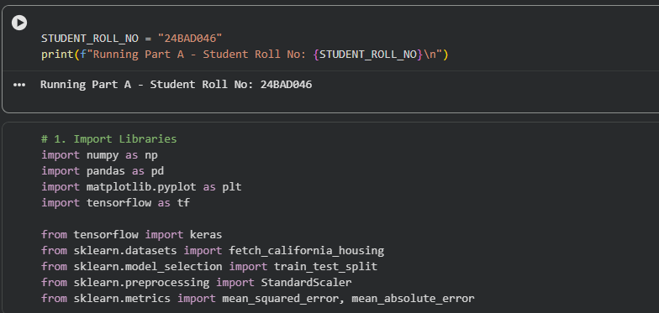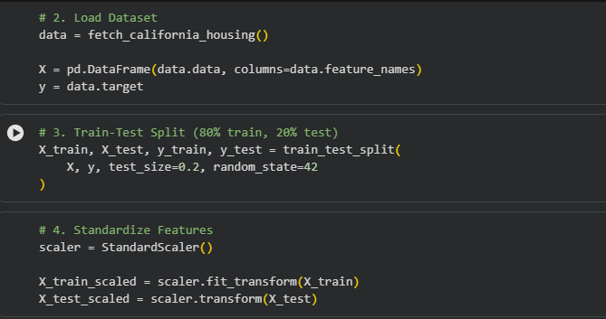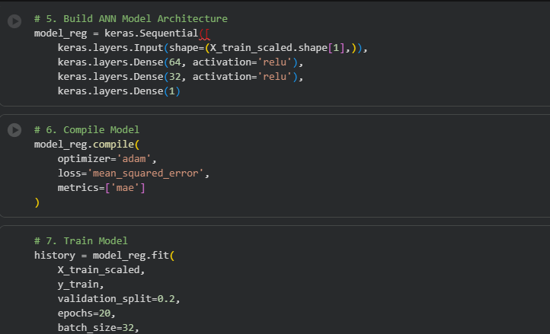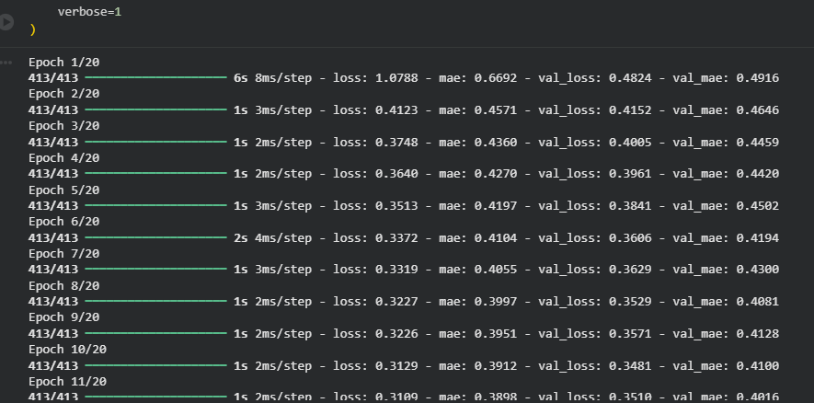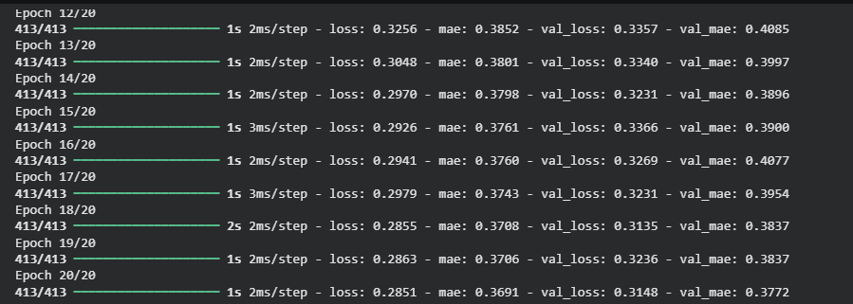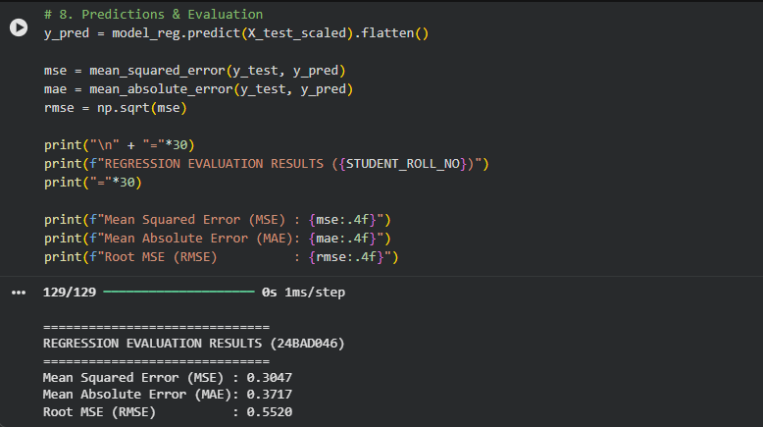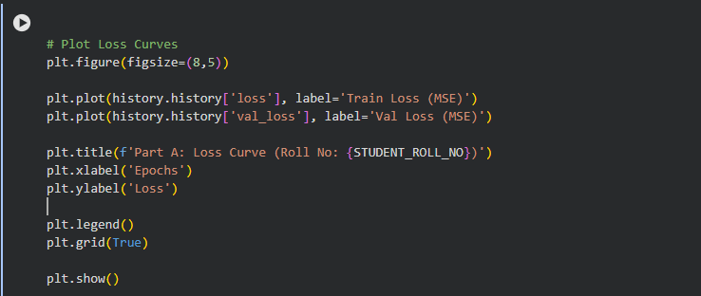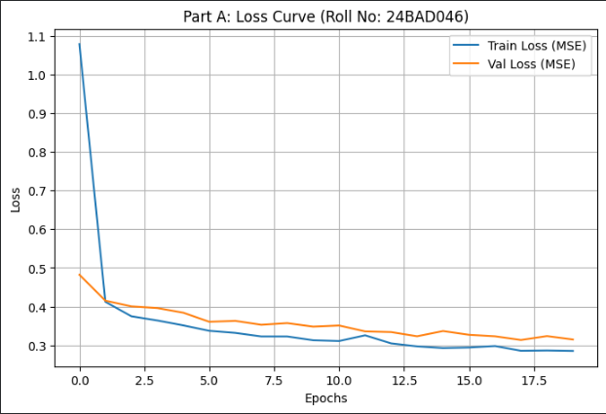

PART B – ANN FOR CLASSIFICATION
DATASET: Breast Cancer Wisconsin Dataset
SOURCE: Scikit-learn
DESCRIPTION
- Samples: 569
- Features: 30
- Classes:
  - Malignant
  - Benign

ALGORITHM
- Import libraries.
- Load Breast Cancer dataset.
- Split dataset.
- Standardize features.
- Design ANN.
- Compile model.
- Train model.
- Predict labels.
- Evaluate:
  - Accuracy
  - Precision
  - Recall
  - F1-score
  - Confusion Matrix

Code:
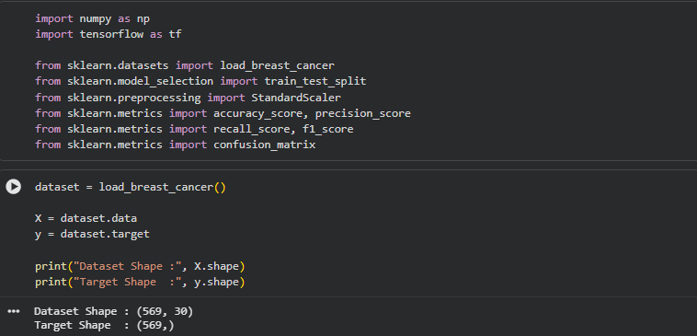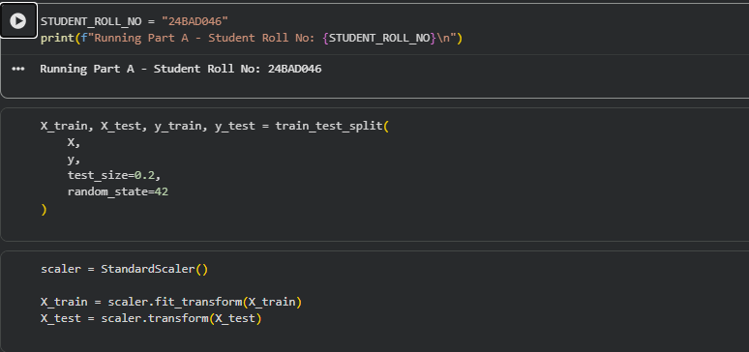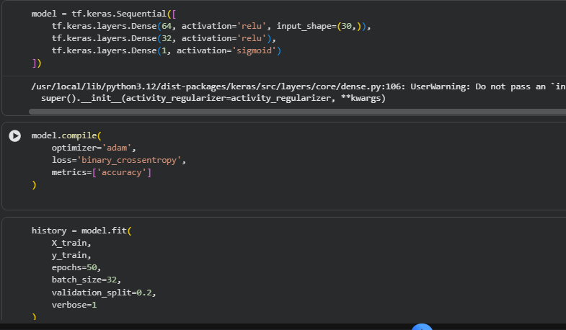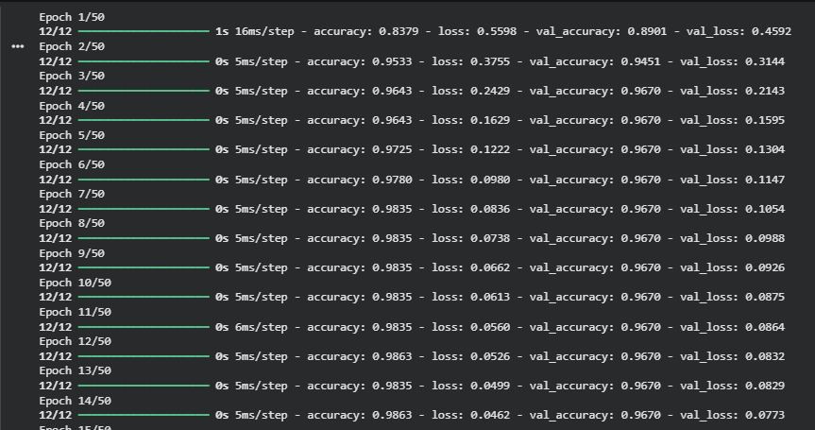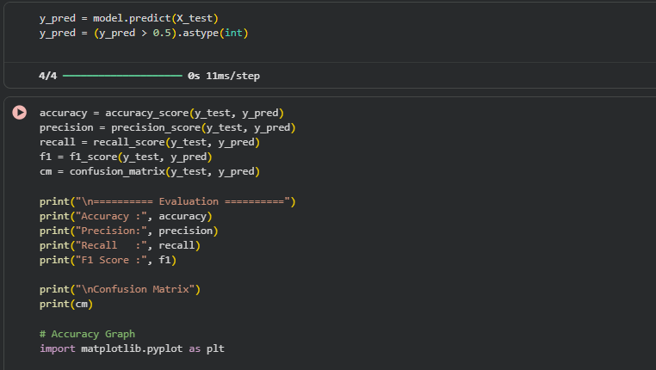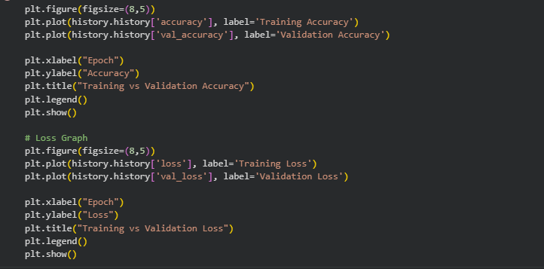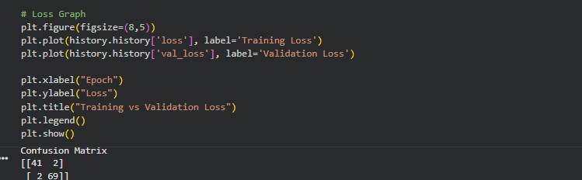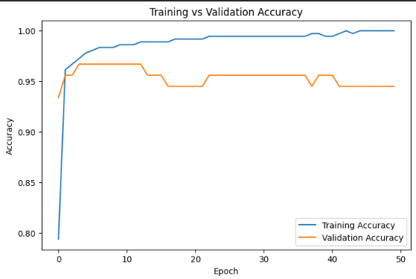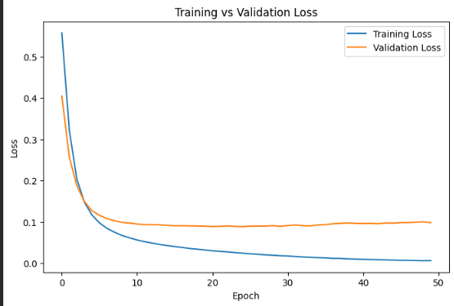

POST-LAB QUESTIONS (PROVIDE BRIEF ANSWERS TO THE FOLLOWING QUESTIONS)

1. Why is the Adam optimizer commonly used in ANN training?
Adam optimizer automatically adjusts the learning rate during training, making the learning process faster, more stable, and efficient for most neural network models.

2. Compare Mean Squared Error (MSE) and Mean Absolute Error (MAE). Which metric is more sensitive to outliers?
- MSE: Calculates the average of squared prediction errors, giving more importance to larger errors.
- MAE: Calculates the average of absolute prediction errors, treating all errors equally.
- More sensitive to outliers: MSE, because squaring increases the effect of large errors.

3. Why is the sigmoid activation function used in binary classification?
The sigmoid function converts the output into a value between 0 and 1, which can be interpreted as the probability of belonging to a particular class.

4. How does increasing the number of hidden layers affect the performance of an ANN?
Adding more hidden layers allows the network to learn more detailed patterns. However, too many layers can increase computation time and may cause overfitting if not handled properly.

5. Compare the evaluation metrics used for regression and classification tasks. Why are different metrics required for these problems?
- Regression: Uses MSE, MAE, and RMSE to measure how close predicted values are to actual values.
- Classification: Uses Accuracy, Precision, Recall, F1-score, and Confusion Matrix to measure how correctly the model predicts class labels.

ASSESSMENT
Description | Max Marks | Marks Awarded
Pre Lab Exercise | 5
In Lab Exercise | 10
Post Lab Exercise | 5
Viva | 10
Total | 30
Faculty Signature

